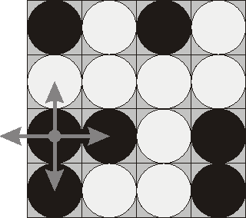

Flip Game
翻转游戏
Time Limit: 1000MS |  | Memory Limit: 65536K
Total Submissions: 11891 |  | Accepted: 5083
Description
Flip game is played on a rectangular 4x4 field with two-sided pieces placed on each
矩形 双面
of its 16 squares. One side of each piece is white and the other one is black and each
广场
piece is lying either it's black or white side up. Each round you flip 3 to 5 pieces, thus changing the color of their upper side from black to white and vice versa. The pieces
上方 反之亦然
to be flipped are chosen every round according to the following rules:
每轮
- Choose any one of the 16 pieces.
- Flip the chosen piece and also all adjacent pieces to the left, to the right, to the
相邻
top, and to the bottom of the chosen piece (if there are any).
底部
Consider the following position as an example:
bwbw
wwww
bbwb
bwwb
Here "b" denotes pieces lying their black side up and "w" denotes pieces lying their
表示
white side up. If we choose to flip the 1st piece from the 3rd row (this choice is shown at the picture), then the field will become:
bwbw
bwww
wwwb
wwwb
The goal of the game is to flip either all pieces white side up or all pieces black side up. You are to write a program that will search for the minimum number of rounds needed to achieve this goal.
Input
The input consists of 4 lines with 4 characters "w" or "b" each that denote game field position.
Output
Write to the output file a single integer number - the minimum number of rounds needed to achieve the goal of the game from the given position. If the goal is initially
最初
achieved, then write 0. If it's impossible to achieve the goal, then write the word "Impossible" (without quotes).
Sample Input
bwwb
bbwb
bwwb
bwww
Sample Output
4
Source
Northeastern Europe 2000

提示：其实每格棋子最多只可以翻转一次（实际是奇数次，但这没意义），只要其中一格重复翻了2次(不论是连续翻动还是不连翻动)，那么它以及周边的棋子和没翻动时的状态是一致的，由此就可以确定这个棋盘最多只能走16步，最多只能有翻出2^16种状态

